**BIKESTORE SQL ANALYSIS**

This bikestore dataset contain 9 tables which are:

1. Production.brands
2. Production.categories
3. Production.products
4. Production.stocks
5. Sales.customers
6. Sales.order_items
7. Sales.orders
8. Sales.stores
9. Sales.staffs

Therefore, here are 10 questions to explore in our Bikestores dataset, along with the queries and brief explanations:

1. What are the available product categories?

SELECT

    category_name

FROM

    production.categories

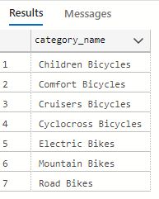

1. How many products does each brand have?

SELECT

    brand_name,

    COUNT(*) as product_count

FROM

    production.brands pb

JOIN production.products pp

    ON pb.brand_id = pp.brand_id

GROUP BY

    brand_name

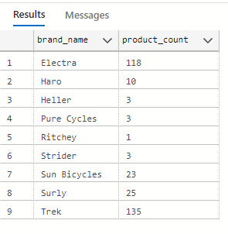

1. Which store has the highest total sales?

SELECT

    top 1

    store_name,

    SUM(order_total) as total_sales

FROM

    sales.stores ss

JOIN

    sales.orders so

    ON  ss.store_id = so.store_id

JOIN

    sales.order_items si

    ON si.order_id = so.order_id

GROUP BY

    store_name

ORDER BY

    total_sales DESC

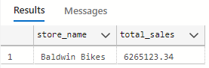

1. What is the average order value?

SELECT

    AVG(order_total) as average_order

FROM

    sales.order_items

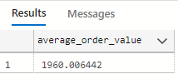

1. Who are the top 5 customers based on total spending?

SELECT

    TOP 5

    Full_Name,

    SUM(order_total) as total_spending

FROM

    sales.customers sc

JOIN

    sales.orders so

    ON  sc.customer_id = so.customer_id

JOIN

    sales.order_items si

    ON  so.order_id = si.order_id

GROUP BY

    Full_Name

ORDER BY

    total_spending DESC

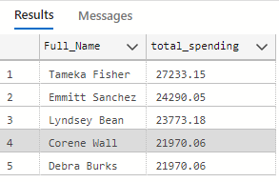

1. How many staff members are employed in each store?

SELECT

    store_name,

    COUNT(*) staff_count

FROM

    sales.staffs ss

JOIN

    sales.stores st

    ON  ss.store_id = st.store_id

GROUP BY

    store_name

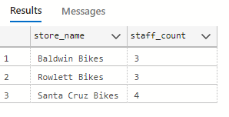

1. Calculate the running total of sales for each store

WITH Running_total AS

    (

SELECT

    store_name

    ,order_date

    ,SUM(order_total) OVER (PARTITION BY store_name ORDER BY order_date) as total_sales

FROM

    sales.stores ss

JOIN

    sales.orders so

    ON  ss.store_id = so.store_id

JOIN

    sales.order_items si

    ON  so.order_id = si.order_id

    )

SELECT

    store_name,order_date, total_sales

FROM

    Running_total

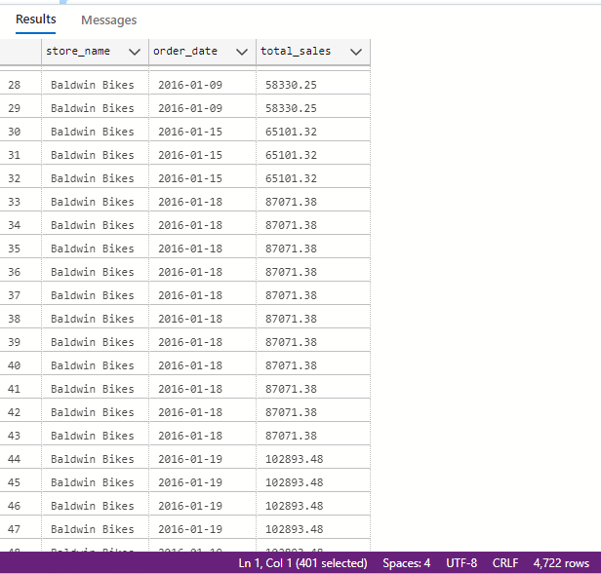

With over 4722 row records returned

1. Determine the top-selling brand in each category

WITH TopBrand AS (

SELECT

    category_name,

    brand_name,

    RANK() OVER (PARTITION BY category_name ORDER BY total_sales DESC) as brand_rank

FROM (

        SELECT

            category_name,

            brand_name,

            SUM(order_total) AS total_sales

        FROM

            production.brands pb

        JOIN

            production.products pp

            ON

                pb.brand_id = pp.brand_id

        JOIN

            production.categories pc

            ON  pc.category_id = pp.category_id

        JOIN

            sales.order_items so

            ON  so.product_id = pp.product_id

        GROUP BY

            category_name, brand_name

)categorybrandsales

    )

SELECT

    category_name, brand_name

FROM

    TopBrand

WHERE

    brand_rank = 1

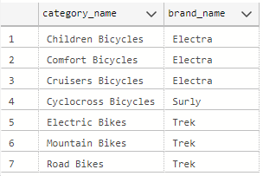

1. Calculate the average sales per store for each category:

SELECT

    category_name,

    AVG(total_sales) AS Avg_sales_per_store

FROM

    (

SELECT

    ss.store_id

    ,category_name

    ,SUM(order_total) AS total_sales

FROM

    sales.stores ss

JOIN

    sales.orders so

    ON  ss.store_id = so.store_id

JOIN

    sales.order_items si

    ON  so.order_id = si.order_id

JOIN

    production.products pp

    ON  si.product_id = pp.product_id

JOIN

    production.categories pc

    ON  pp.category_id = pc.category_id

GROUP BY

    ss.store_id,

    category_name

    ) StoreCategorySales

GROUP BY

    category_name

ORDER BY

    Avg_sales_per_store DESC

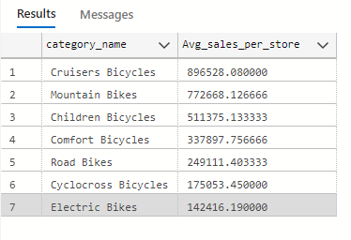

1. Identify the top 3 products with the highest sales in the last quarter:

SELECT

    TOP 3

    product_name

    ,SUM(order_total) as total_sales

FROM

    sales.order_items si

JOIN

    production.products pp

    ON  si.product_id = pp.product_id

JOIN

    sales.orders so

    ON  si.order_id = so.order_id

WHERE

    order_date >= DATEADD(QUARTER, DATEDIFF(QUARTER, 0, 2018) - 1 , 0)

GROUP BY

    product_name

ORDER BY

    total_sales DESC

